**Skill bases assessment 3**

**Group 2:**

**Angular activity project code:**

<html>

<head>

   <title>Angular JS Forms</title>

   <script src="https://ajax.googleapis.com/ajax/libs/angularjs/1.3.14/angular.min.js"></script>

   <meta name="viewport" content="width=device-width, initial-scale=1">

   <link href="https://cdn.jsdelivr.net/npm/bootstrap@5.1.1/dist/css/bootstrap.min.css" rel="stylesheet">

   <script src="https://cdn.jsdelivr.net/npm/bootstrap@5.1.1/dist/js/bootstrap.bundle.min.js"></script>

   <link rel="stylesheet" href="https://maxcdn.bootstrapcdn.com/bootstrap/3.4.1/css/bootstrap.min.css">

   <script src="https://ajax.googleapis.com/ajax/libs/jquery/3.5.1/jquery.min.js"></script>

   <script src="https://maxcdn.bootstrapcdn.com/bootstrap/3.4.1/js/bootstrap.min.js"></script>

   <style>

      table,

      th,

      td {

         border: 1px solid grey;

         border-collapse: collapse;

         padding: 5px;

      }

      table tr:nth-child(odd) {

         background-color: #f2f2f2;

      }

      table tr:nth-child(even) {

         background-color: #ffffff;

      }

   </style>

</head>

<body>

   <div class="jumbotron">

      <h2>Welcome to this page, Please fill your details and preferences</h2>

   </div>

   <h4>Choose the appropriate dropdown option</h4>

   <div class="container">

      <div class="dropdown">

         <button class="btn btn-default dropdown-toggle" type="button" data-toggle="dropdown">Form A

            <span class="caret"></span></button>

         <ul class="dropdown-menu">

            <li><a href="#">Form A</a></li>

            <li><a href="#">Form B</a></li>

            <li><a href="#">Form C</a></li>

         </ul>

      </div>

   </div>

   <div ng-app="mainApp" ng-controller="studentController">

      <form name="studentForm" novalidate>

         <table border="0">

            <tr>

               <td>Enter first name:</td>

               <td><input name="firstname" type="text" ng-model="firstName" required>

                  <span style="color:red" ng-show="studentForm.firstname.$dirty && studentForm.firstname.$invalid">

                     <span ng-show="studentForm.firstname.$error.required">First Name is required.</span>

                  </span>

               </td>

            </tr>

            <tr>

               <td>Enter last name: </td>

               <td><input name="lastname" type="text" ng-model="lastName" required>

                  <span style="color:red" ng-show="studentForm.lastname.$dirty && studentForm.lastname.$invalid">

                     <span ng-show="studentForm.lastname.$error.required">Last Name is required.</span>

                  </span>

               </td>

            </tr>

            <tr>

               <td>Email: </td>

               <td><input name="email" type="email" ng-model="email" length="100" required>

                  <span style="color:red" ng-show="studentForm.email.$dirty && studentForm.email.$invalid">

                     <span ng-show="studentForm.email.$error.required">Email is required.</span>

                     <span ng-show="studentForm.email.$error.email">Invalid email address.</span>

                  </span>

               </td>

            </tr>

            <tr>

               <td>Phone: </td>

               <td><input name="Phone" type="text" ng-model="Phone" length="100" required>

                  <span style="color:red" ng-show="studentForm.email.$dirty && studentForm.email.$invalid">

                     <span ng-show="studentForm.email.$error.required">Phone is mandatory.</span>

                     <span ng-show="studentForm.email.$error.email">Invalid phone number</span>

                  </span>

               </td>

            </tr>

            <tr>

            <tr>

               <td>Marital status:</td>

               <td>

                  <select id="mstatus" name="mstatus">

                     <option value="Prefer not to say" selected>Prefer not to say</option>

                     <option value="Unmarried">Unmarried</option>

                     <option value="Prefer not to say">Married</option>

                  </select>

               </td>

            </tr>

            </tr>

            <tr>

               <td>Select the location:</td>

               <td>

                  <select id="location" name="location">

                     <option value="Trivadrum" selected>Trivandrum</option>

                     <option value="Cochin">Cochin</option>

                     <option value="Bangalore">Bangalore</option>

                     <option value="Mysore">Mysore</option>

                     <option value="Chennai">Chennai</option>

                  </select>

               </td>

            </tr>

            <tr>

               <td>

                  <h4>Languages Known:</h4>

               </td>

               <td>

                  <input type="checkbox" id="Language 1" name="English" value="English">

                  <label for="English"> English</label><br>

                  <input type="checkbox" id="Language 2" name="Hindi" value="Hindi">

                  <label for="Hindi"> Hindi</label><br>

                  <input type="checkbox" id="Language 3" name="Spanish" value="Spanish">

                  <label for="Spanish"> Spanish</label><br>

                  <input type="checkbox" id="Language 4" name="Malayalam" value="Malayalam">

                  <label for="Malayalam"> Malayalam</label><br>

                  <input type="checkbox" id="Language 5" name="Tamil" value="Tamil">

                  <label for="Tamil"> Tamil</label><br><br>

            </tr>

            </td>

            <tr>

               <td>

                  <h4>Select your preferences</h4>

               </td>

               <td>

                  <h4>Choose either one of the option</h4>

                  <label id="1"><input type="radio" id = "Eat" name = "myact" value = "Eat" >Eat</label><span> or </span><label id="2"><input type="radio" id = "Sleep" name = "myact" value = "Sleep" >Sleep</label><br>

                  <label id="3"><input type="radio" id = "Tall" name = "myact1" value = "Tall" >Tall</label><span> or </span><label id="4"><input type="radio" id = "Short" name = "myact1" value = "Short" >Short</label><br>

                  <label id="5"><input type="radio" id = "Run" name = "myact2" value = "Run" >Run</label><span> or </span><label id="6"><input type="radio" id = "Walk" name = "myact2" value = "Walk" >Walk</label><br>

                  <label id="7"><input type="radio" id = "Talk" name = "myact3" value = "Talk" >Talk</label><span> or </span><label id="8"><input type="radio" id = "Play" name = "myact3" value = "Play" >Play</label><br>

                  <label id="9"><input type="radio" id = "Dance" name = "myact4" value = "Dance" >Dance</label><span> or </span><label id="10"><input type="radio" id = "Jump" name = "myact4" value = "Jump" >Jump</label><br>

            </tr>

            </td>

            <tr>

               <td>

                  <button ng-click=<a href="#" class="btn btn-info" role="button">For Reset</a></button>

               </td>

               <td>

                  <button ng-disabled="studentForm.firstname.$dirty &&

                        studentForm.firstname.$invalid || studentForm.lastname.$dirty &&

                        studentForm.lastname.$invalid || studentForm.email.$dirty &&

                        studentForm.email.$invalid" ng-click=<a href="#" class="btn btn-info" role="button">Submit

                     Button</a></button>

               </td>

            </tr>

         </table>

      </form>

   </div>

   <script>

      var mainApp = angular.module("mainApp", []);

      mainApp.controller('studentController', function ($scope) {

         $scope.reset = function () {

            $scope.firstName = "Hemanth";

            $scope.lastName = "";

            $scope.email = "";

            $scope.mstatus = "Married/Unmarried";

            $scope.Phone = "";

         }

         $scope.reset();

      });

   </script>

</body>

</html>

**Angular activity output:**

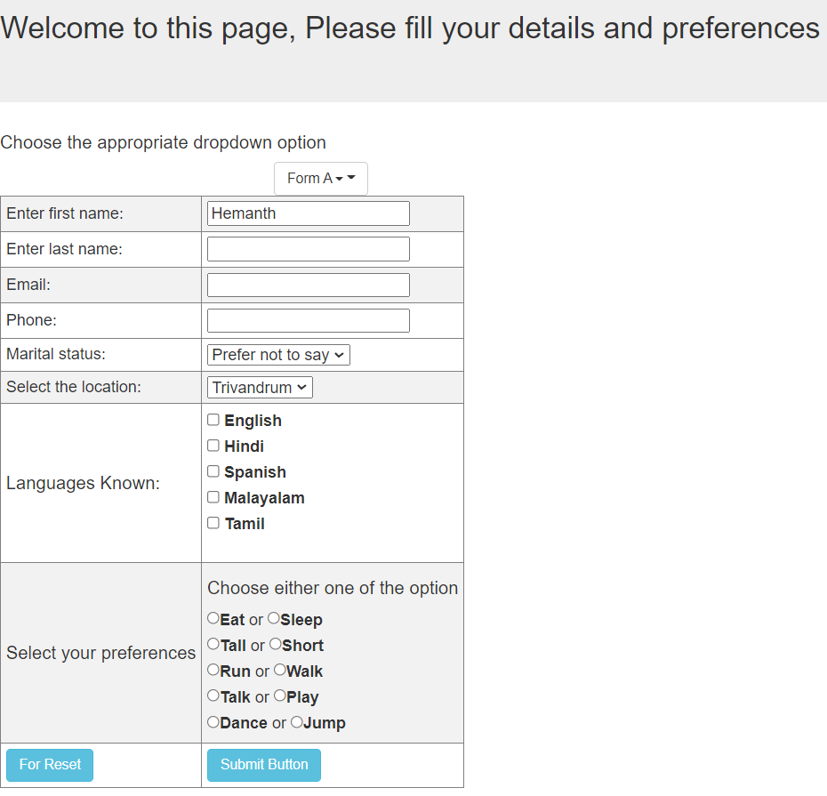

**Cypress activity code for the above angular page:**

describe('simple Test', function () {

    // Test case

       it('Scenario 1', function (){

         cy.visit("http://192.168.0.4:5500/Project-specfile.html");

          cy.url().should('include', 'Project')

       });

       it('Scenario 2', function (){

         cy.get('[type="radio"]').first().check()

      });

      it('Scenario 3', function (){

         cy.get('[type="checkbox"]').first().check()

      });

      it('Scenario 4', function (){

         cy.title().should('eq', 'Angular JS Forms')

      });

      it('Scenario 5', function (){

         cy.get('[name="firstname"]').type(' kumar')

         cy.get('[name="lastname"]').type('A V')

         cy.get('[name="email"]').type('hemanth@gmail.com')

         cy.get('[name="Phone"]').type('949186559595')

      });

      it('Scenario 6', function (){

         cy.get('[value="Jump"]').check()

      });

      it('Scenario 7', function (){

         cy.get('[value="Spanish"]').check()

      });

      it('Scenario 8', function (){

         cy.get('#location').select('Cochin')

      });

      it('Scenario 9', function (){

         cy.get('#location').select('Trivandrum')

      });

      it('Scenario 10', function (){

         cy.visit("http://192.168.0.4:5500/Project-specfile.html")

         cy.get('#mstatus').select('Married')

         });

      });

**Cypress activity output:**

